Papaya Leaves Cure Dengue?

Dr. Madhubanti Mukherjee³, Dr. Shayeri Banerjee²,
Dr. Sneha Bhowmik², Dr. SohiniChakroborty², Dr. SubhashisSaha²,
Dr. Udita Nag², Dr. Priyambada Sharma², Dr. SwarnaliNaskar²,
Dr. VandanaMaroo², Dr. Nripen Bhaumik¹

ABSTRACT:

Dengue has become a common name in households in the community due to the havoc increase in its incidence rates in the recent times. And as most of the readers might know, it is a disease that can only be treated symptomatically. In such a grave situation, a new discovery that papaya leaf extract cures dengue is like a god-sent blessing. This article is a review on the recent dengue status in our country and state and the role of papaya extract on curing dengue.
Keywords: dengue, pandemic, vector, thrombocytopenia, shock, arbovirus, hemorrhage, platelets, NSAID

1. INTRODUCTION:
As monsoon sweeps across the country, it brings with it various vector borne diseases, dengue being the most rampant and the deadly one in recent times. Instances of dengue usually go up between August and November, when India sees high rainfall. Stagnant water all over the cities makes an ideal breeding ground for mosquitoes. Global incidence of dengue has drastically increased in the last few years. According to WHO, there are about 390 million reported cases of dengue fever worldwide till now, out of which 90 million require medical treatment. There has been a doubling up of cases from 2014 to 2015. Worst hit city was Delhi with 1800 cases of dengue fever.
³Junior Resident, ²Interns, ¹Professor; Dept. of Neurosurgery, KPC Medical College and Hospital, Kolkata; charmwings@gmail.com

Incidence has been getting worse with each passing year, 2016 being no exception. And this has become a major concern for the country. Be it the 65year old lady from Kolkata or the teenage girls from Jafrabad, victims from all age groups have succumbed to this deadly vector borne disease.

There were about 220 dengue deaths and 99,913 cases of dengue fever last year, with the present count being 60 deaths and 27,879 cases throughout the country so far this year. West Bengal has topped the list this time leaving 23 dead and total numbers of affected persons since January being 5,639. Most of the cases were reported from districts like Howrah, Hooghly, North 24 parganas and South 24 parganas. There has also been an alarming rise of dengue positive patients in Delhi, Karnataka, Dehradun, Orissa and Telangana. While Karnataka is facing a scarcity of beds in the state hospitals with a whopping 834+ cases of dengue fever, Delhi is battling with staff crunch in the city hospitals, as not only the common people, even the doctors are falling prey to this disease.
Much to our surprise, an interesting connection has been found between papaya leaves and its ability to combat this virus. This article will emphasize on this new concept, here's hoping it will prove to be our 'knight in shining armour' in dealing with this disease.

2. WHAT CAUSES DENGUE AND HOW:

Dengue is actually a viral disease and the causative virus belongs to the“arbovirus”family and is capable of infecting human, causing disease. These viruses are actually carried by a type of mosquito called Aedes aegypti, which acts as a vector. Hence it is called a vector borne disease. These infections may be asymptomatic or may lead to:-
- “classical” dengue fever, or
- Dengue haemorrhagic fever without shock, or
- Dengue haemorrhagic fever with shock

Dengue is a self-limiting disease and represents the majority of cases of dengue infection. A prevalence of Aedes aegypti and Aedes albopictus together with the circulation of dengue virus of more than one type in any particular area tends to be associated with outbreaks of Dengue Haemorrhagic Fever/ Dengue Shock Syndrome.

Of all arthropod-borne viral diseases, dengue fever is the most common. Dengue fever is one of the most important emerging diseases of the tropical and sub-tropical regions, affecting urban and periurban areas. The geographical distribution of the disease has greatly expanded and the number of cases has increased dramatically in the past 40 years. Some 2.5-3 billion people live in areas where dengue virus can be transmitted. A pandemic 1998, in which 1.2 million cases of dengue fever and dengue haemorrhagic fever were 56 countries, was unprecedented. It is estimated that each year 50 million infections occur with 500,000 cases of dengue haemorrhagic fever and at least 12,000 deaths, mainly among children, although fatalities could be twice as high.
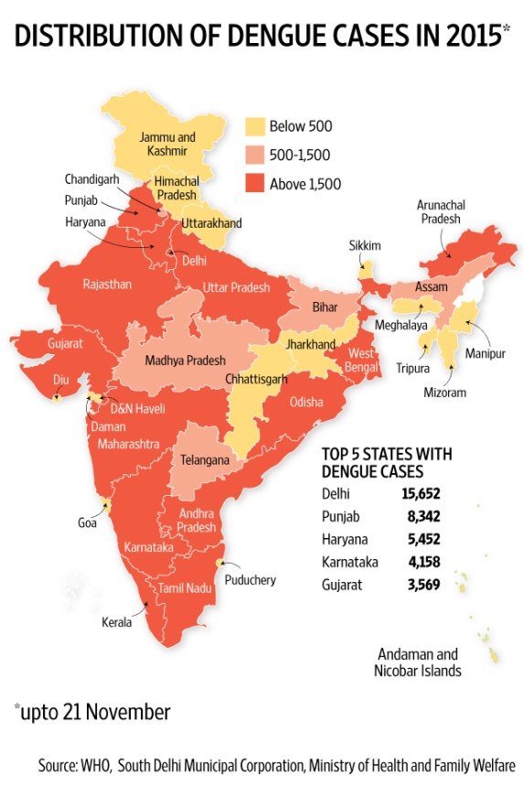

Fig-1. This is a picture showing the state-wise distribution of dengue cases in India in 2015

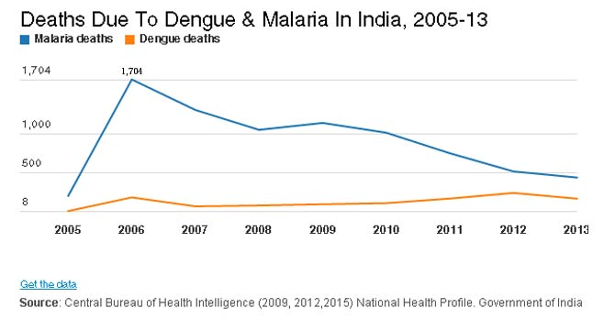

Fig- 2. This is a chart showing a comparison between deaths due to dengue and
deaths due to malaria in India during 2005 to 2013.

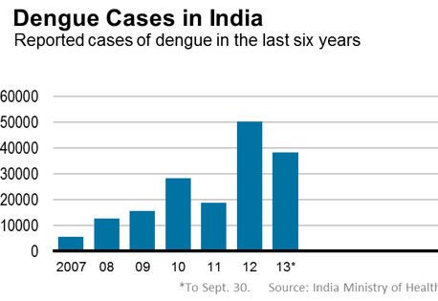

Fig-3. Dengue Cases in India (Source: India, Ministry of Health)

This Chart shows the number of reported cases of Dengue in India in the last six years since 1996, NAMP has been monitoring dengue situation in the country. Government of India has issued guidelines on prevention and control of dengue which has been discussed later. The first case of probable dengue fever is in a Chinese medical encyclopedia from the Jin Dynasty (265-420 AD) which referred to a “water poison” associated with flying insects. First clinical case report dates from 1789 of 1780 epidemic in Philadelphia is by Benjamin Rush, who coined the term “break bone fever” because of the symptoms of myalgia and arthralgia. The term Dengue fever came into general use only after 1828. In India, the first epidemic of clinical dengue-like illness was recorded in Madras (now Chennai) in 1780 and the first virologically proved epidemic of Dengue fever occurred in Calcutta (now Kolkata) in 1963-64. In India, dengue virus was first isolated in 1945.

Dengue is an acute viral infection, caused by at least 4 serotypes (1, 2, 3 and 4) of dengue virus. Dengue fever can occur epidemically or endemically. Epidemics may be explosive and often start during the rainy season when the breeding of the vector mosquitoes (e.g., Aedes aegypti) is generally abundant. Temperature also plays an important role in the transmission of dengue virus by mosquitoes.

The reservoir of infection is both man and mosquito. The transmission cycle is “Man-mosquito-Man”. Aedes aegypti is the main vector. Dengue outbreaks have also been attributed to Aedes albopictus, Aedes polynesiensis and several species of Aedes scutellaris complex.
The Aedes mosquito becomes infective by feeding on a patient from the day before onset to the 5th day of illness. After an extrinsic incubation period of 8-10 days, the mosquito becomes infective, and is able to transmit the infection.

3. THE EFFECTS OF DENGUE ON THE BODY:

Dengue Fever mainly includes acute febrile illness with headache, retro-orbital pain, myalgia (muscle pain), arthralgia (joint pain), rash, reduction in white blood cells and platelets.
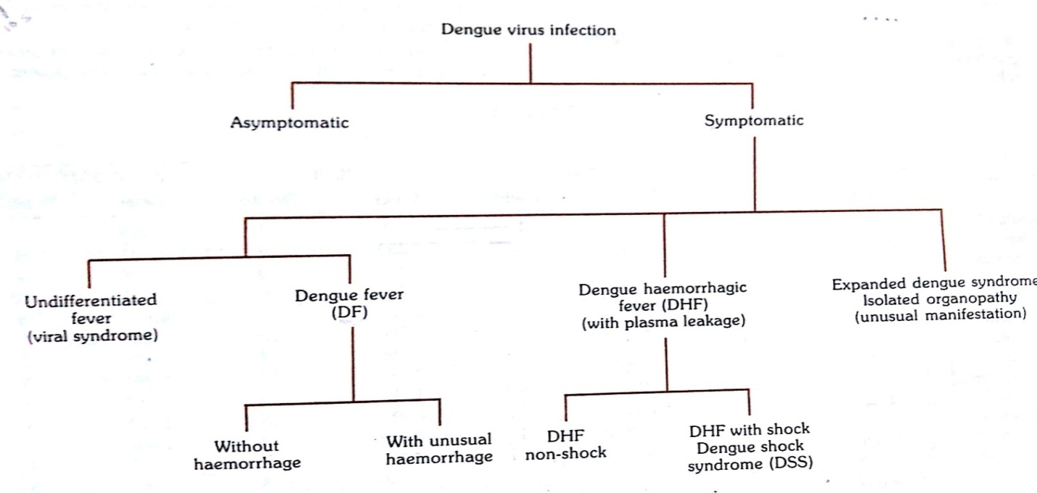
Whereas Dengue Haemorrhagic Fever presents with fever of Acute onset with Evidence of plasma leakage and fluid accumulation in various body cavities.(ascites, pleural effusion,etc) and the most cardinal sign being Haemorrhagic manifestations like Ecchymosis, Purpura, Bleeding from GI tract in the form of black tarry stools, hematemesis or bleeding from gums, Epistaxis etc. The next stage i.e. Dengue Shock Syndrome presents with Features of Dengue Haemorrhagic Fever with Tachycardia, Weak pulse, Delayed capillary refill, Cold extremities, Pulse Pressure< 20 mm of Hg with increased Diastolic BP, Hypotension by age defined as Systolic BP<90 mm of Hg in less than 5 years of age.

4. HOW TO DIAGNOSE DENGUE:
Dengue is diagnosed usually by testing for the NS1 antigen in blood and also by Immunoglobulin (IgG and IgM testing). Analysis of haematological parameters: platelet count and haematocrit are important and are part of diagnosis of dengue infection. Other special tests for virus detection are PCR, Elisa etc, but these aren’t routinely done.

5. HOW DENGUE IS MANAGED:
The management of dengue is mostly symptomatic. Lots of fluid intake is suggested to patients in the form of ORS, fruit juice, etc. For patients who are unable to intake fluids orally IV fluids are given. Electrolytes and sugars that are lost are replenished. For fever Paracoetamol is given as NSAIDS are contra-indicated. (They increase bleeding tendency and gastro enteritis). For people with very low platelet counts Fresh Frozen plasma maybe transfused to replenish platelets in blood. Nowadays a new mode of treatment is said to have a great effect in Dengue patients. Let’s have a look.

6. IS PAPAYA LEAF EXTRACTS THE ULTIMATE CURE?
Nowadays it is being said and apparently it is proved that papaya leaf extract (scientific name: Carica papaya) has a significant role in replenishing platelets and there by acting as a cure to dengue patients. Papaya plant is a soft wooded single stemmed perennial tree, 2-10 m height with a crown of large palmate leaves emerging from apex of trunk, native to Central America. It is lactiferous as specialized cells called lactifers occur in tissues and secrete latex. This latex is dispersed throughout plant tissues. C.papaya contains active compounds like chymopapain, papain, caricain, glycine endopeptidases, lipase, hydrolase, an alkaloid carpaine, glucoside carposide, malic acid, quinic acid, manghaslin, clitorin, nicotiflorin, rutin, tocopherol, ascorbic acid, flavonoids and other anti-inflammatory components.

Ayurveda or Ayurvedic medicine is a branch of medicine with its roots in the Indian subcontinent. It is one of the world's oldest holistic (whole body) healing systems. At the onset we must realize that papaya is not mentioned in the classical Ayurvedic texts. The plant itself is not of Indian origin but that does not mean that there can be no basis for Ayurvedic practitioners to use papaya.
If we look into papaya from an Ayurvedic perspective, it has been named as Eranda Karkati, which literally means "Castor Cucumber". The incorporation of a plant as a drug source becomes complete in Ayurveda only when we clearly understand on which dosa (functional principles) and dhaatu (tissues) it will work, what are the desirable and undesirable effects of the plant. Although the use of papaya is not clearly given in the classical Ayurvedic text books but in some parts the use of its leaves only (and not fruits or seeds) for increasing platelet count has been attributed. In sum, we can conclude that more studies need to be conducted and observation and analysis has to be done to gain a thorough understanding of uses of papaya in curing dengue fever.

7. STUDIES CONDUCTED ON EFFECTS OF PAPAYA LEAF AND FINDINGS:

7.1. Study Conducted In Pakistan (Asian Pacific Journal Of Tropical Biomedicine):

In a 45 year old patient bitten by carrier mosquitoes study was carried out for the efficacy of papaya leaf extract. Extract was prepared in water and aqueous solution of leaves was administered to patient infected twice daily for consecutive 5 days. Before administration blood samples were analyzed. Platelet, WBC and Neutrophil counts were 55,000/ul, 3.7×10^3/ul and 46%. Subsequently blood samples were rechecked after administration of extract. Platelet, WBC and Neutrophil count increased to 1,68,000/ul, 7.7×10^3/ul and 78.3%.

7.2. Study Conducted In Sri Lanka:
The potential role of fresh C. papaya leaves on haematological and biochemical parameters with toxicological changes were studied in Murine model in Medical Research Institute, Sri Lanka, University of Peradeniya. 3 experimental trials were carried out from May 2011 to May 2012 using 3 sets of mice. Fresh middle stage leaves were washed blended without adding water. Mixture is filtered to obtain pure extract and stored at 4degree C until use. 36 mice were taken. Fresh extract 0.2 ml/ mouse was administered to 18 mice. Platelet count, WBC, RBC, PCV, SGOT, SGPT, Creatinine were serially estimated at intervals. In study group platelet and RBC count increased day 21 onwards whereas in the control group no change was observed.

7.3. Study Conducted in Rajasthan:
In Bikaner from September 2013 to Jan 2014 a study was carried out comprising of 400 cases aged>16, Ns1 + with platelet count< 1.5 lakh. All participants were randomized into 2 groups, study and control. The study group was given papaya leaf extract capsule of 500mg once daily along with routine supportive care for 5 days. Control group was given only routine supportive care. Daily CBC, Platelet count, HCT, LFT RFT were observed. It was observed that average platelet transfusion requirement in study group< control group (0.685 units/patient vs 1.19 units/ patient).

7.4. Study Conducted in Bangalore:
A pilot study was conducted to investigate platelet increasing property of carica leaf extract in patients with dengue fever. An open labelled RCT was carried out at 2 centres on 30 subjects in patients with thrombocytopenia. The intervention group received leaf extract tablets thrice daily for 5 days. The study group of 14 was administered 1100mg tab thrice daily for 5 days. Platelet count was monitored daily.

8. HOW PAPAYA LEAF ACTS:
Possible mechanisms by which platelets reduce in the body in dengue (thrombocytopenia) are impaired thrombopoesis, peripheral platelet destruction, altered proliferative capacity, inhibition of differentiation of megakaryocytes and progenitor apoptosis. Active components of leaf extract inhibit immune mediated platelet destruction, bone marrow suppression and stabilize membrane of infected cells in dengue. ALOX 12 gene and PTAFR are triggered which are responsible for megakaryocytic proliferation.

8.1. Advantages of C. Papaya over Other Options:
- Better and viable option
- Palatable and appropriately formulated
- Reduced side effects
- Reduced cost of hospitalization
- Cost effective
- More accessible
- Avert mortalities
- Reduce fever duration, fluid leak
- Reduce conversion of dengue fever to DHF
- Rapid rise of WBC and platelets

8.2. Disadvantages of Conventional Platelet Transfusion and Tpo Agonists (Eltrombopag, Romiplastin)
- High cost
- Less accessible
- Higher adverse effects
- No rise in WBC count

8.3. When to Administer?
On the 1st day on being diagnosed as NS1 + at primary care level.

8.4. Preparation:

Fresh healthy mature papaya leaves are obtained from a fruit bearing tree, leaves are washed in running water, chopped into small pieces, weighed. 50 gm leaves put into a mortar and pestle. 50 ml boiled cool water is added with 25gm sugar. The above mixture is pounded well for 15 mins till a uniform pulp is made. Pulp is mixed and kept for 30 mins, squeezed by hand and stored for 24 hrs at 4degree C. Extract is shaken before use.

8.5. Methods of Administration:
Syrup- 30 ml thrice daily in adults and 5- 10 ml in children until fully recovered. Sips of cold water are given along with to overcome the bitter taste. Tablets are also available.

9. CONCLUSION:
Recent rise in trend of admissions with dengue in all hospitals clearly suggest that dengue is a severe threat to all the age groups. And C.papaya has been a divine blessing in disguise helping to relieve the severity of dengue. It seems to be something we have been all looking for. Let’s hope that in the coming years this newly discovered cure will reduce the incidence rates of dengue worldwide.

REFERENCES
- Asian Pacific Journal of Tropical Biomedicine ( NisarAmad, Ijaz Mohammad, LubnaFazal)
- A.C. Gowda, N. Vijay Kumar, P.N.Kasture, K.H.Nagabhushan- Micro Labs Ltd. Bangalore
- Journal of the Association of Physicians of India Volume 64 June 2016
- PatilShetty, S.Bhindeet.al- Evaluation of platelet augmentation activity of carica papaya leaf aqueous extract in rats, Journal of Pharmacognosy and Phytochemistry3.70
- Preventive and Social Medicine by K. Park
- Research Council of Sri Lanka Department of Pathobiology, Faculty of Veterinary Medicine and Animal Science, University of Peradeniya
- www.wikipedia.org
- www.who.int

