Learning through Augmented Reality

Sudhakar C. Agarkar*

Abstract:

Twenty first century has witnessed an unprecedented growth in technology influencing human lives in a variety of ways. Apart from day to day activities it has made its headway into schools and colleges. The teaching learning process adopted in educational institutions has undergone drastic changes in recent years. Augmented Reality (AR) is one such technological tool that has a potential to help the learners to understand scientific concepts in an interactive mode. Hence, an attempt has been made to develop AR based laboratory activities and field test them in selected schools. The feedback received from both teachers and students is quite positive. Encouraged by this feedback a full-fledged package for learning school science is being designed by a start-up company EDU360 Knowledge Solutions Private Limited. This article briefly describes the concept of AR and the way it can be used to enhance science education.

- Introduction :

Since the later part of the nineteenth century our lives are influenced greatly by Information and Communication Technology (ICT). The developments in ICT have enabled us to communicate with each other quite fastgiving rise to a ‘connected society’. ICT developments have led to the availability of information for Anyone, Anytime and Anywhere (A3). Present society is, therefore, called as ‘Knowledge Society’. Developments in ICT have also influenced school education. E-learning as emphasized by Zemsky and Massey (2005) has a tremendous potential still unexplored. In many developed countries blackboards are replayed by smart boards that facilitate effective teacher pupil interaction. A computer and LCD projector are invariably made available to each classroom in these countries. Websites have become sources of information both for students and teachers. Realizing the influence of ICT on school education NASA (National Aeronautics and Space Administration) has come out with an idea of COTF (Classroom of the Future). Established in different parts of the country COTF is trying to develop new methods of knowledge exploration using the available facility of ICT (www.cotf.edu). At the Open University in UK (the first open university of the world) technology is being profusely used for teaching through distance mode. The Knowledge Media Information (KMI) of the UKOU is working in the area of making use of ICT to improve teaching learning process in schools (www.kmi.open.ac.uk).

*VPM’s Academy of International Education and Research, Thane, Maharashtra;Former Professor, TIFR, Mumbai, India.
On the background of this international scenario we get a dismal picture when we look at the school education in India. It is widely known that there is a large diversity in Indian education system. India boasts to be an IT giant developing software for multinational companies. It is a fact that our foreign earnings of software exports run into billions of dollars. It is a pity that our schools, however, have not been benefitted by these developments. There is a dire need to change this situation. This article describes an attempt to use modern technology to enthuse, engage and educate the young lads. Specifically it outlines the efforts made to develop a mobile app using the modern technology known as Augmented Reality (AR) to facilitate the learning of school science. Let us first understand the meaning of Augmented Reality.

- Augmented Reality :

Augmented Reality (AR) is a technical term coined by Tom Caudell in 1990. He was a researcher in Boeing, a company that makes planes. Milgram et al defined AR as augmenting natural feedback to the operator with simulated cues. Klopfer et al defined AR as a situation in which a real world context is dynamically overlaid with coherent location or context sensitive virtual information. It can also be seen as a continuum between real and virtual environment. AR is being used in developing games from the time it was made available to technical experts.

Educators with technical inclinations have attempted to use AR in education. A large number of articles have been published in journals all over the world describing the use of AR in teaching learning process. Phil Diegmann, Manuel Schmidt-Kraepelin, Sven van den Eynden and Dirk Basten of the University of Cologne in Germany undertook a detailed literature survey. They presented the result of their work during 12th International Conference on Wirtscafts informatics held in Osnabuk, Germany in March 2015. The title of the research paper was “Benefits of Augmented Reality in Educational Environments – A Systematic Literature Review”. They have identified five directions for which AR was put to use in education.

- Discovery Learning : These applications are often used in museums, astronomical
education and at historical places.
- Objects Modeling : This application is used mostly in architectural education.
- AR Books : They provide 3D object and offer a scope for interactive learning.
- Skills Training : With a focus on the acquisition of mechanical skills.
- AR Gaming : They provide educators with highly interactive and visual forms
of learning.

The researchers found out a total of 67 benefits. Out of which 14 were crucial that were clustered into 6 groups.
- State of Mind : Increased motivation, attention, concentration and satisfaction.
- Teaching Concepts: Increased student centered learning and collaborative learning
- Presentation : Increased details, information accessibility and interactivity.
- Learning Type : Improved learning curve, and increased creativity.
- Content Understanding: Increased spatial ability and enhanced memory
- Costs : Reduced expenses

- Development of AR Labs:

EDU360, a start-up, has designed a mobile app using the power of Augmented Reality. Named as “Sahi Labs”, it has concept based experiments in school science. Providing 3D experience these activities are interactive in nature where students have enough opportunities to participate and control the proceedings of the activity. They can be viewed using a mobile phone with a camera. For that one needs to direct the mobile camera to a surface with high contrast. A dozen experiments from the science syllabus of tenth standard CBSE (Central Board of Secondary Education) were designed and made available free of costs both on android as well IOS platforms. The feedback received from different parts of the world has been quite positive.

- Field Testing :

Field testing of Sahi Labs Mobile App was undertaken in schools following both CBSE and state curricula. The feedback received is very encouraging. It was found that the app provides an immersive experience to the users. Students and teachers both enjoy performing these experiments on the screen. In doing so their conceptual understanding gets enhanced considerably. A full-fledged package explaining the concepts in high school science will be launched soon. Encouraged by this feedback EDU360 now plans to develop a similar app for upper primary as well as higher secondary classes.
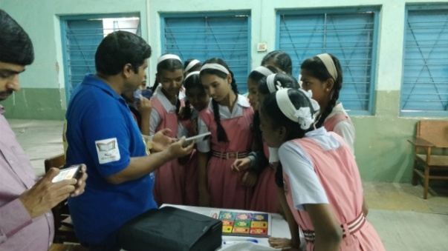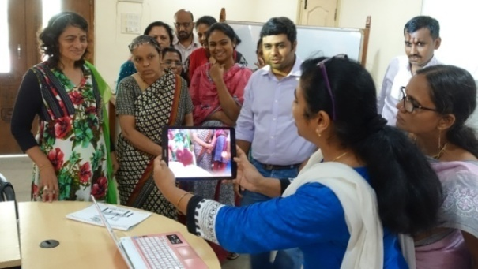
High school students engrossed Teacher educators watching the
in watching the app app with enthusiasm

- Conclusions :

Experiences gained from Sahi Labs indicate that there is a tremendous potential in using technology to improve school science education in India. The augmented reality is establishing itself so well that it can be used to design activities related to complex natural phenomena. The power of AR is such that it can be used to help to gain the understanding of scientific concepts easily. Concentric efforts are needed to develop requisite material. At the same time the mentality of the teachers need to be prepared to use content based on modern technology. The number of smart phone user is increasing day by day. At the same time the internet facility is penetrating in the country quite fast. It is hoped that this improved facility will enable even the rural schools to use the Sahi Labs Mobile App for the benefit of its students.
References
- Diegemann, Phil, et.al. (2015); Benefits of Augmented Reality in Educational Environments – A Systematic Literature Review, Paper presented in12th International Conference on Wirtscaftsinformatic held in Osnabuk, Germany in March 2015.
- Zemsky, Robert and Massey, William (2005); Stalled: E-learning as thwarted innovation, In Carr Chellam, Alison A. (Ed.) Global Perspectives on E-learning: Rhetoric and Reality, New Delhi: Sage Publication

